Section 1.
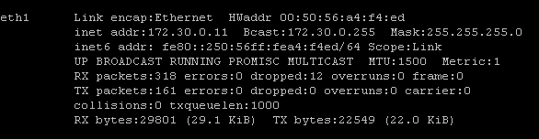

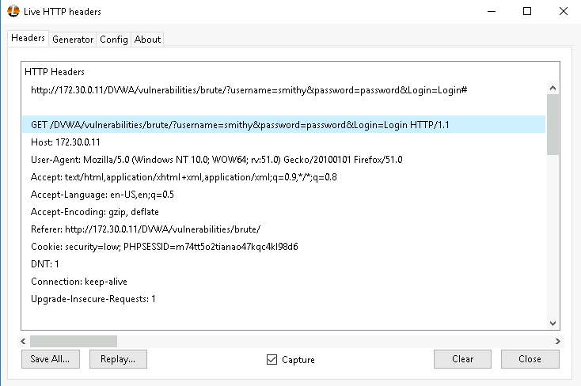
His password was password, took me a couple of tries. I think I got it earlier; the screen doesn’t really change when it logs in.

The type of information identified by the Live HTTP Headers add-on is information like HTTP request and response information during web interactions. It reveals request details such as HTTP methods (GET), URLs, headers like User-Agent, Referer, and cookies (e.g., session data), as well as response details like status codes (200 OK), server information (e.g., Apache/2.2.22), caching policies, and content type. This tool provides insights into client-server communication, helping with debugging, penetration testing, and identifying web application vulnerabilities.
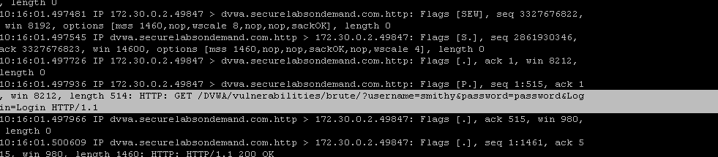
Section 2.

Section 3.
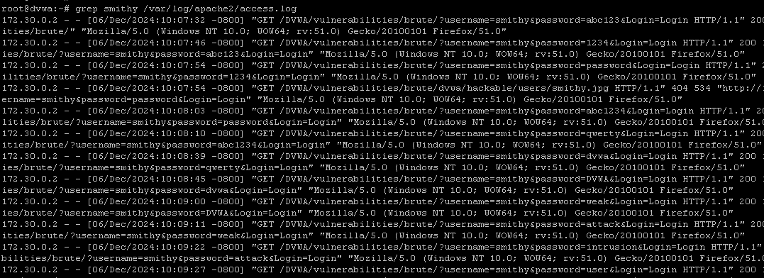
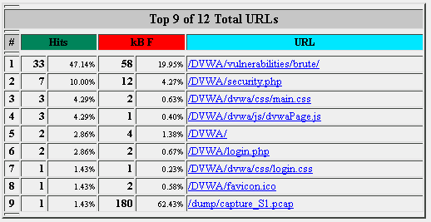

Section 4.
Webtrends Vs Google Analytics
Webtrends is a platform that provides insights into user behaviors, customer journeys, and measure marketing effectiveness. It specializes in enterprise level analytics and is made for larger organizations.
Google Analytics is a tool used to track web visitor behavior, user interactions, and traffic sources. It is made for smaller to medium sized businesses.
Both tools excel in delivering actionable data but are tailored to different levels of complexity and organizational requirements.

